UNIT TITLE: DESIGN AND ANALYSIS OF ALGORITHMS

UNIT CODE : BIT3209

GROUP MEMBERS

Dennis maina
Bit/2019/42252

Erick mbugua.
Bit/2019/39904

Allan Juma
BIT/2019/88893

Abderehman Hassan
BIT/2021/80833

Mohamed jattan
BIT/2017/82421

Ayub Macharia
Bit/2017/70167

ALGORITHMS DISCUSSED

- Huffman Algorithm
- Knapsack Algorithm
- Merge Sort Algorithm

GITHUB PROFILE

https://github.com/mohatrust/Design-and-Analysis-of-algorithms

HUFFMAN ALGORITHM

Huffman coding is a type of greedy algorithm developed by David A. Huffman during the late 19th century. It is one of the most used algorithms for various purposes all over the technical domain. This algorithm is commonly found in almost all programming languages like C, C++, Java, Python, JavaScript, etc.

Huffman coding is a greedy algorithm frequently used for lossless data compression. Therefore, a basic principle of Huffman coding is to compress and encode the text or the data depending on the frequency of the characters in the text.

The basic idea behind the Huffman coding algorithm is to assign the variable-length codes to input characters of text based on the frequencies of the corresponding character. So, the most frequent character gets the smallest code, and the least frequent character is assigned with the largest code.

Here, the codes assigned to the characters are termed prefix codes which means that the code assigned to one character is not the prefix of the code assigned to any other character. Using this technique, Huffman coding ensures that there is no ambiguity when decoding the generated bitstream.

Using Huffman coding, we will compress the text to a smaller size by creating a Huffman coding tree using the character frequencies and generating the code for each character.

Remember that we encode the text while sending it, and later, it is necessary to decode it. Hence, the decoding of the text is done using the same tree generated by the Huffman technique.

Algorithm for Huffman Coding

- 1. initiate a priority queue 'Q' consisting of unique characters.
- 2. sort the priority queue according to the ascending order of frequencies
- 3. for all the unique characters inside the queue:
- Initialize a new Node 'a'
- Return the minimum value of Q and assign it to the left child of 'a'
- Return the next minimum value of Q and assign it to the right Child of 'a'
- find the sum of both returned values and assign it as the value of 'a'
- insert the value of 'a' into the tree
- 4. repeat the same process until all unique characters of 'Q' are visited
- 5. Return root node

What is Huffman coding used for?
Huffman coding is used for conventional compression formats like GZIP, etc
It is used for text and fax transmission
It is used in statistical coding
Huffman coding is used by multimedia codecs like JPEG, PNG, MP3, etc

Time Complexity
The time complexity of Huffman coding is O(n logn), where n is the number of unique characters. It is because the encoding of the text is depended on the frequency of the characters.

Reference :
https://favtutor.com/blogs/huffman-coding

Knapsack Algorithm
This algorithm is a part of the dynamic programming. In dynamic programming we solve the bigger problem by diving it into smaller problems. Keep the result of the smaller problems in cache and then solving the bigger problem using the cache.

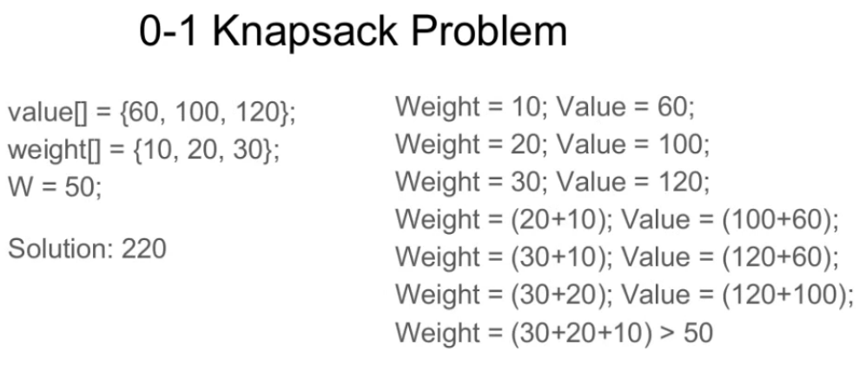

Recursion by Brute-Force algorithm OR Exhaustive Search.
Approach: A simple solution is to consider all subsets of items and calculate the total weight and value of all subsets. Consider the only subsets whose total weight is smaller than W. From all such subsets, pick the maximum value subset.
Optimal Sub-structure: To consider all subsets of items, there can be two cases for every item.
- Case 1: The item is included in the optimal subset.
- Case 2: The item is not included in the optimal set.
Therefore, the maximum value that can be obtained from ‘n’ items is the max of the following two values.
- Maximum value obtained by n-1 items and W weight (excluding nth item).
- Value of nth item plus maximum value obtained by n-1 items and W minus the weight of the nth item (including nth item).
If the weight of ‘nth’ item is greater than ‘W’, then the nth item cannot be included and Case 1 is the only possibility.

Complexity Analysis:
- Time Complexity: O(2n).
As there are redundant sub-problems.
- Auxiliary Space :O(1) + O(N).
As no extra data structure has been used for storing values but O(N) auxiliary stack space(ASS) has been used for recursion stack.

Since sub problems are evaluated again, this problem has Overlapping Sub-problems property
reference: https://www.geeksforgeeks.org/0-1-knapsack-problem-dp-10/

Merge Sort
sorting algorithm that is considered as an example of the divide and conquer strategy. So, in this algorithm, the array is initially divided into two equal halves and then they are combined in a sorted manner. We can think of it as a recursive algorithm that continuously splits the array in half until it cannot be further divided. This means that if the array becomes empty or has only one element left, the dividing will stop, i.e. it is the base case to stop the recursion. If the array has multiple elements, we split the array into halves and recursively invoke the merge sort on each of the halves. Finally, when both the halves are sorted, the merge operation is applied. Merge operation is the process of taking two smaller sorted arrays and combining them to eventually make a larger one.
Pseudo code :
• Declare left variable to 0 and right variable to n-1
• Find mid by medium formula. mid = (left+right)/2
• Call merge sort on (left,mid)
• Call merge sort on (mid+1,rear)
• Continue till left is less than right
• Then call merge function to perform merge sort.
Algorithm:

step 1: start
step 2: declare array and left, right, mid variable
step 3: perform merge function.
merge sort(array,left,right)
merge sort (array, left, right)
if left > right
return
mid= (left+right)/2
merge sort(array, left, mid)
merge sort(array, mid+1, right)
merge(array, left, mid, right)
step 4: Stop

Time Complexity: O(n logn), Sorting arrays on different machines. Merge Sort is a recursive algorithm and time complexity can be expressed as following recurrence relation.
T(n) = 2T(n/2) + θ(n)
The above recurrence can be solved either using the Recurrence Tree method or the Master method. It falls in case II of Master Method and the solution of the recurrence is θ(nLogn). Time complexity of Merge Sort is θ(nLogn) in all 3 cases (worst, average and best) as merge sort always divides the array into two halves and takes linear time to merge two halves.
Auxiliary Space: O(n)
Space Complexity :
• In merge sort all elements are copied into an auxiliary array
• so N auxiliary space is required for merge sort.
Reference: https://www.geeksforgeeks.org/merge-sort/

